**Ec2 Instance Creation**

***Here you will learn how to create a new instance in AWS EC2***

*Follow the given steps :*

1. **For creating EC2 instances, Select EC2 from compute.**

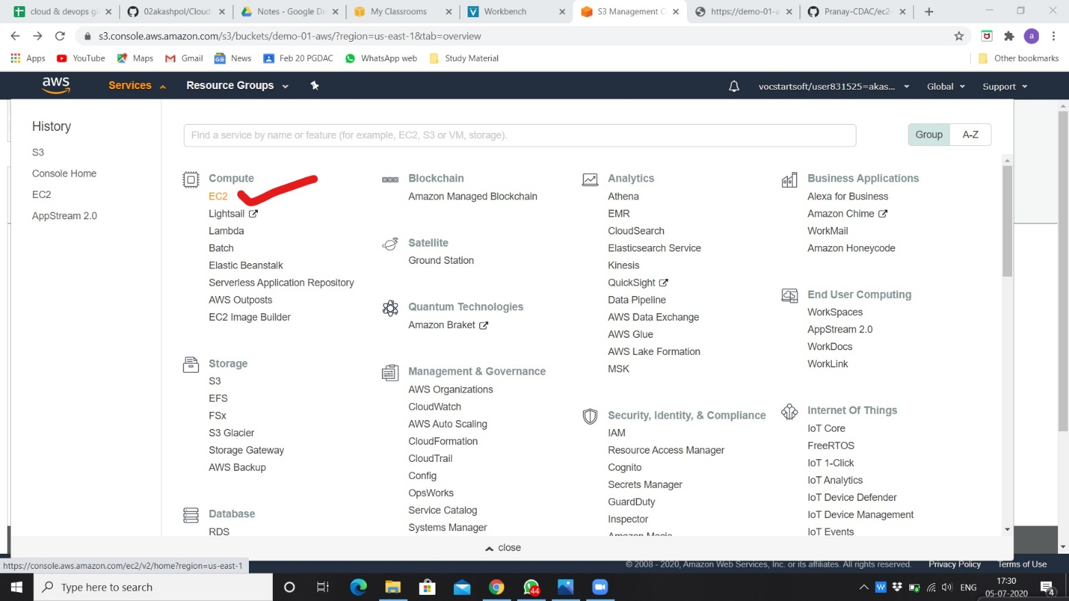

1. **Launching instance.**

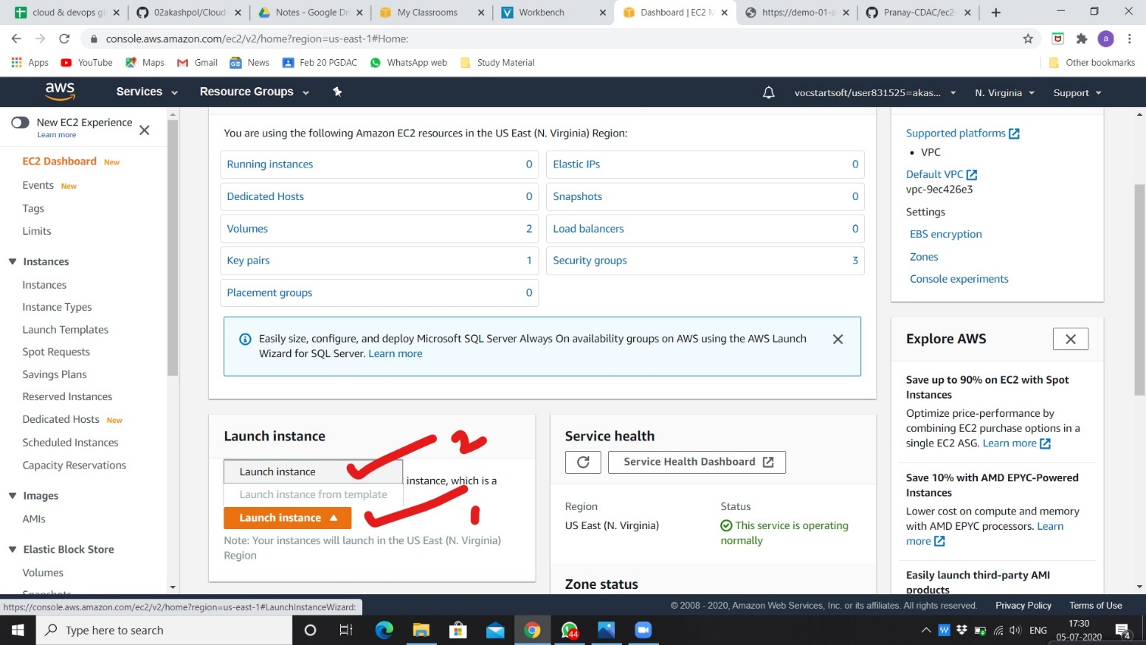

1. **Selection AMI of basic version as per our requirement.**

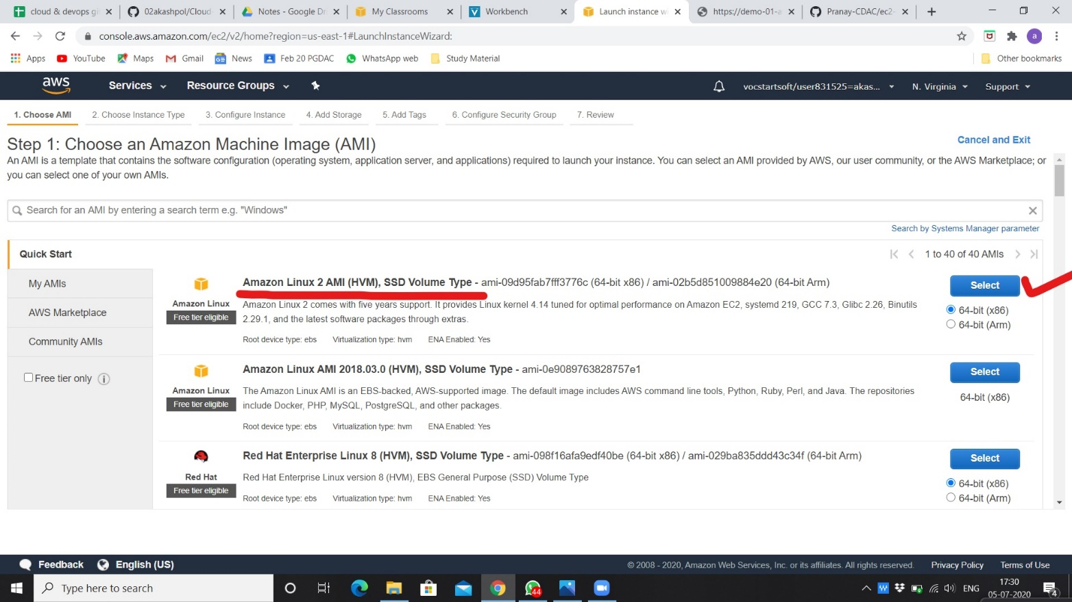

1. **Selection instance type as per requirement.**

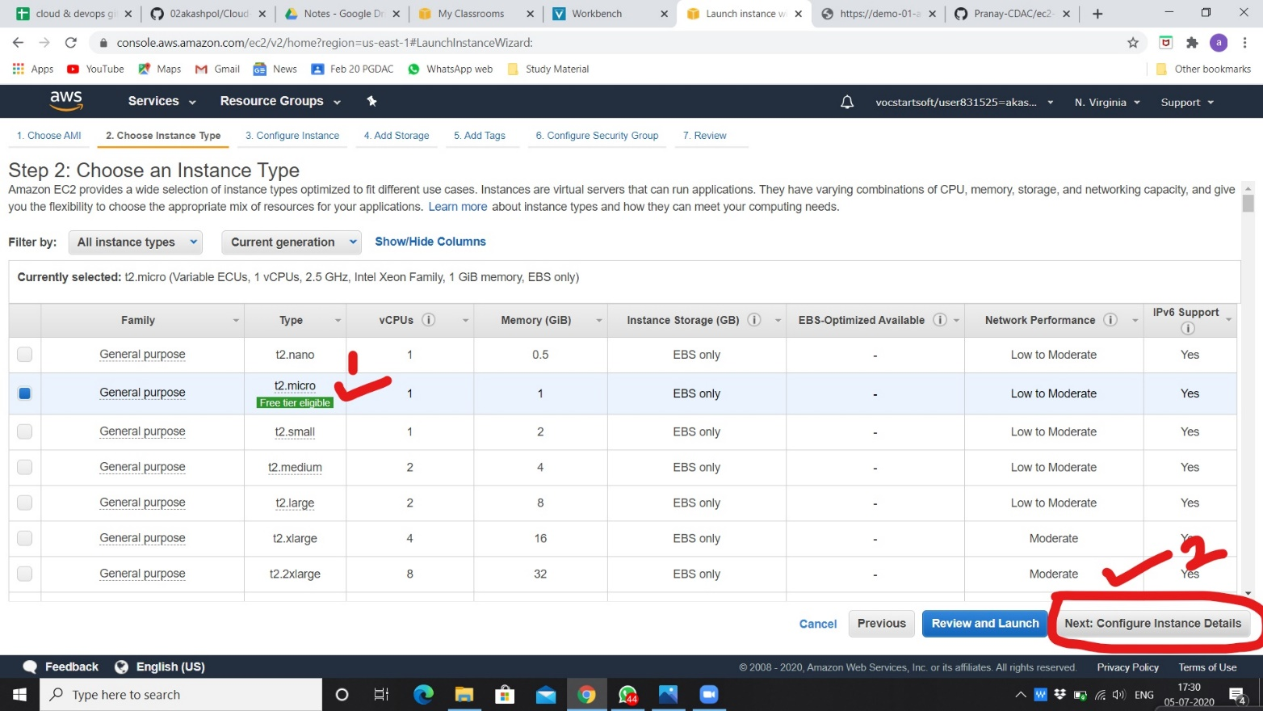

1. **Configuring instance click on add storage.**

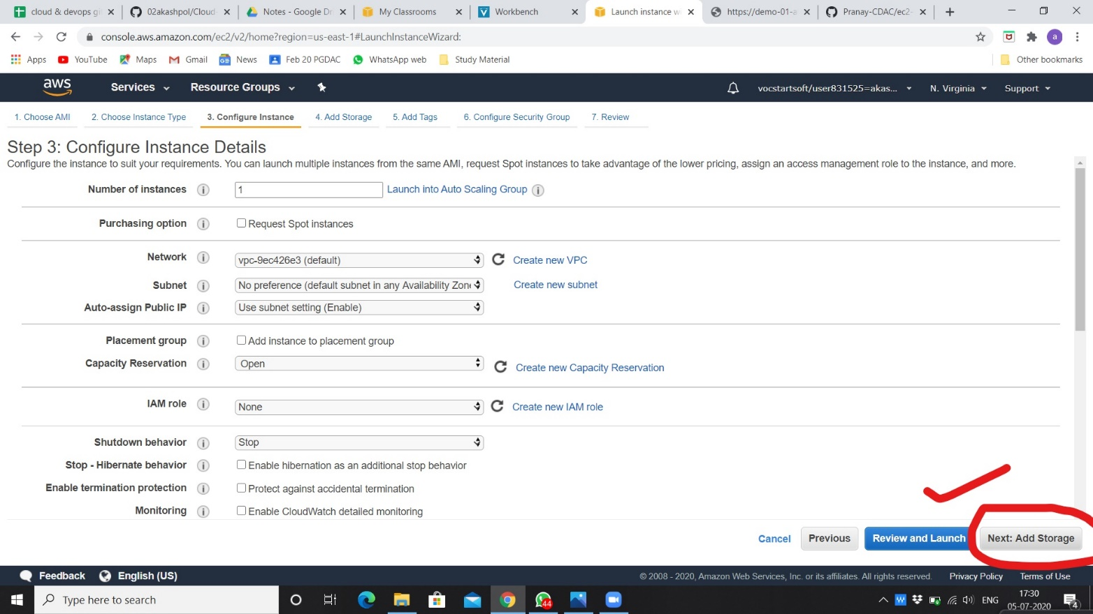

1. **Adding storage capacity as per requirement.**

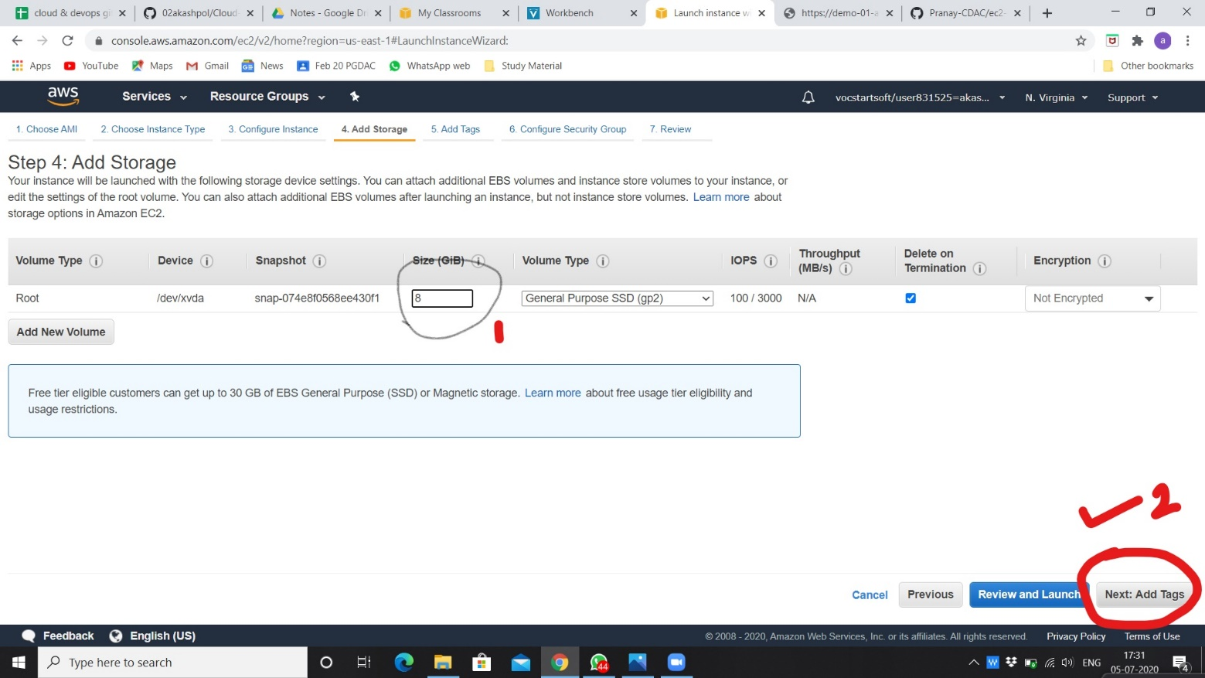

1. **Adding tag.**

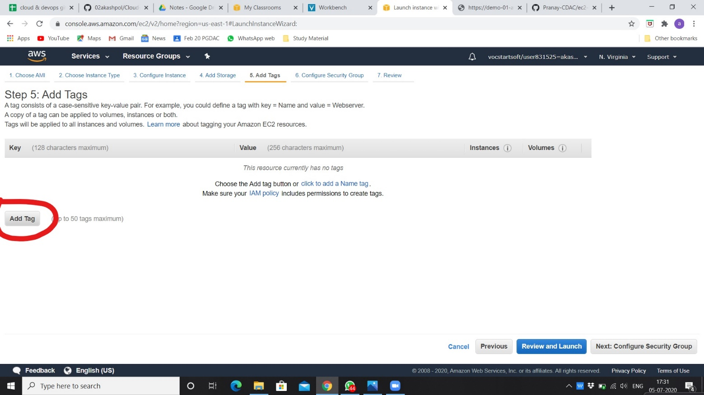

1. **Giving name to key. Add more tag as per your requirement.**

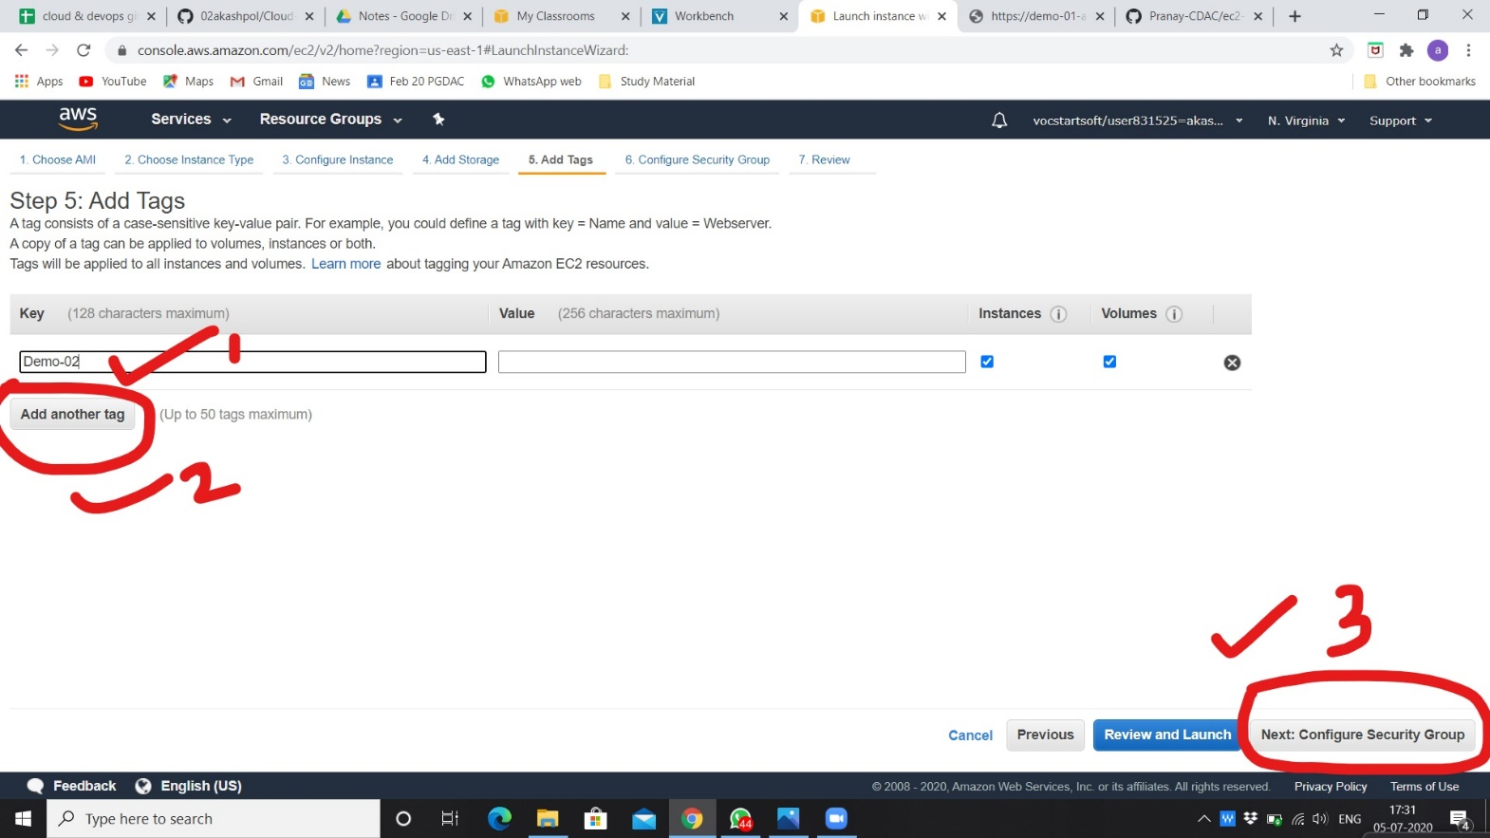

1. **Configuring security group and click on review and launch.**

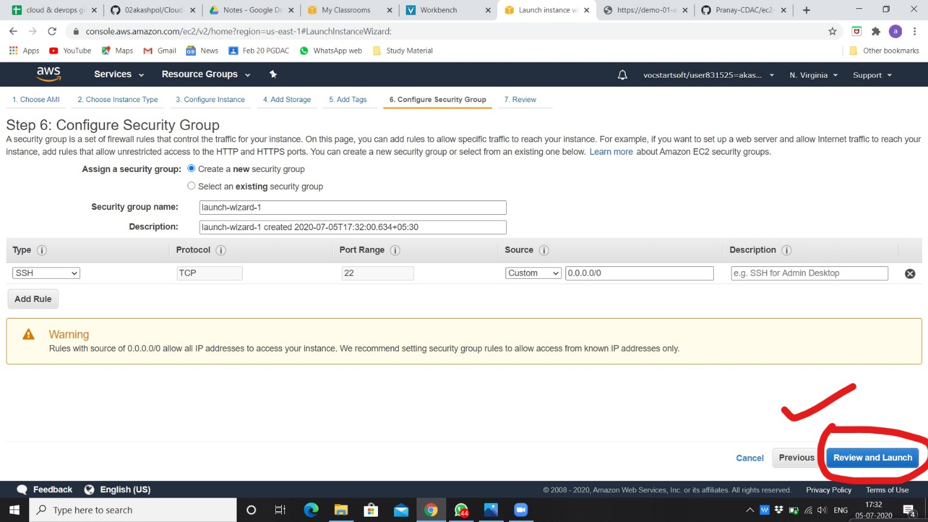

1. **Reviewing all properties as per our selection and click on launch.**

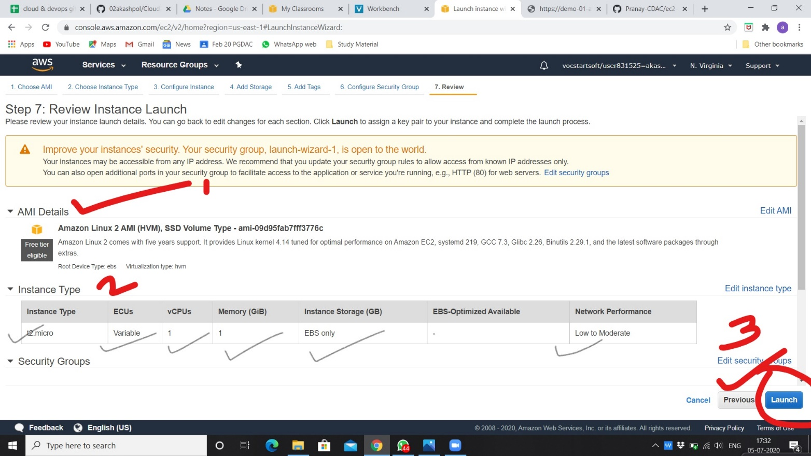

1. **Creating new key pair and give name to it. Download and keep with you that file for using that instance on mobaxterm application.**

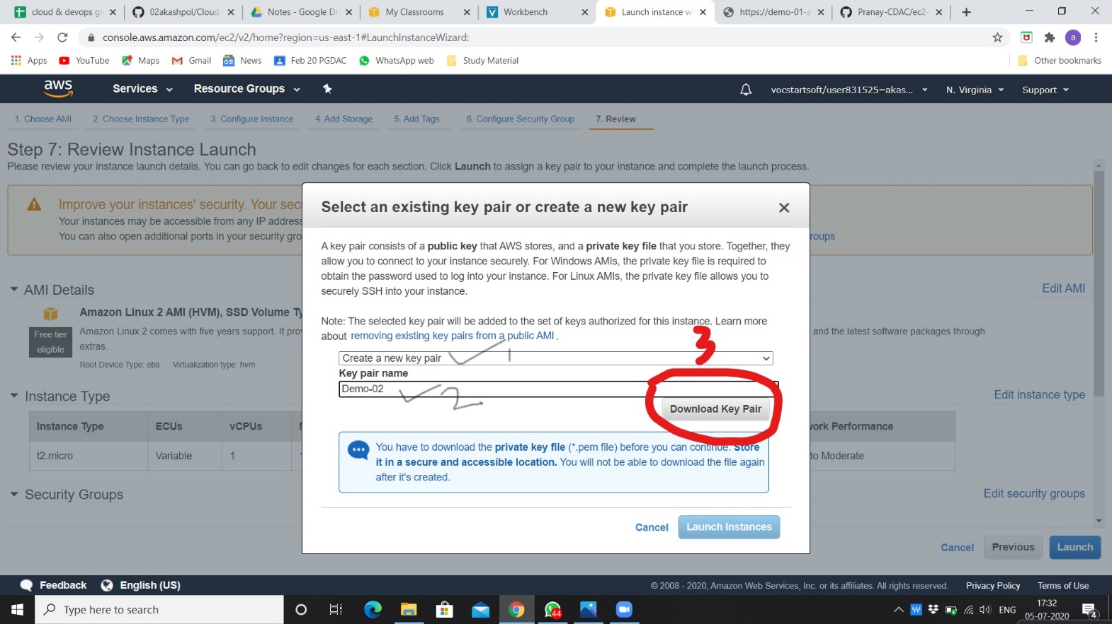

1. **Click on view instances.**

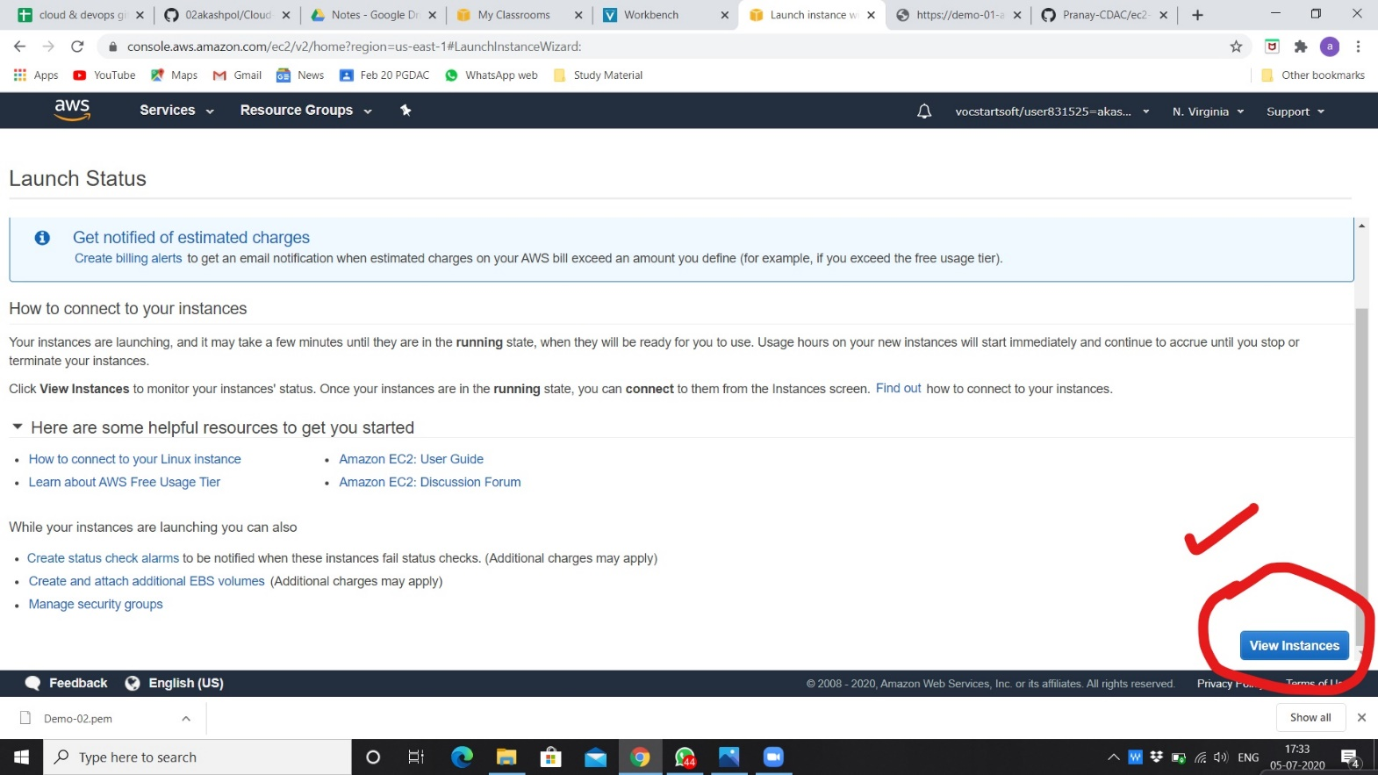

1. **After launching instances, created instance is pending for activation.**

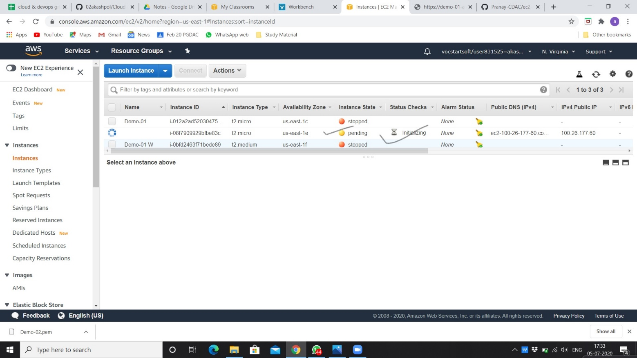

1. **Instance is created successfully and in running state. You can rename it and use that IP for mobaxterm application.**

